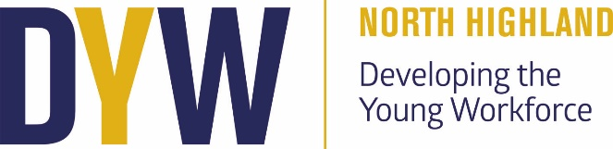

DYW Update
Parent Council Meeting 01/10/24

Recent Activities:
We’ve had an exciting and productive term with several DYW activities aimed at giving students practical insights into various career pathways.

Business Class Visit to Reids Bakery
Our National 5 Business class recently visited Reids Bakery, where students were given an in-depth tour and learned about the different processes involved in running a business and manufacturing. It was a fantastic opportunity for them to see firsthand how a local business operates, and the steps involved in producing goods on a larger scale.

Hospitality Session with Andrew Mackay
Andrew Mackay from The Caithness Collection delivered a lunch-time session for students interested in the hospitality industry. This session provided valuable insights into the skills and opportunities available in this sector, giving students a clearer understanding of potential career paths in hospitality.

Travel and Tourism Visit to the Airport
Our Travel and Tourism class had the opportunity to visit the local airport, where they explored various departments, including security, the fire department, and air traffic control. This visit offered a behind-the-scenes look at how an airport operates, giving students a better understanding of career opportunities within the aviation and travel industries.

Accounting Guest Speakers from Reid & Fraser
Two accountants from Reid & Fraser visited our National Accounting class and shared their career journeys, highlighting the different pathways into the accounting profession. This was an informative session that gave students real-life examples of how they can pursue careers in this field.

Denchi Visit for Chemistry and Physics Classes
Denchi representatives visited all National and Higher Chemistry and Physics classes, offering students an exciting opportunity to learn more about their work. They also held a lunchtime drop-in session where students could test and interact with batteries, providing hands-on experience in STEM.

#NoWrongPath Campaign
Our #NoWrongPath campaign was a great success this term. Many of our teachers shared their career stories, highlighting the varied routes they took to reach their current positions. These stories were featured daily on our school noticeboards, encouraging students to feel reassured that there are many pathways to success.

Overall, it has been a busy and rewarding period, with plenty of opportunities for students to engage with professionals across a range of industries. We look forward to continuing this momentum and providing more enriching experiences for our students in the coming months.

Kind regards,
Alice Nicolson

Dyw.north@dywnh.scot

