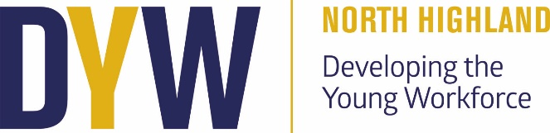

DYW Update
Parent Council Meeting 12/11/24

Recent Activities:
I’m pleased to provide an update on the recent Developing the Young Workforce (DYW) activities aimed at enhancing students' skills and awareness of career opportunities through practical learning and inspiring workshops.

1. Drones in Construction Workshop
Recently, our Higher and National Engineering Science students participated in an interactive Drones in Construction workshop. This hands-on session allowed students to fly drones, survey different points of interest, and gain an understanding of how drones are used in construction and other industries. Students learned about the growing role of technology in engineering and construction sectors, gaining valuable insights into how these fields are evolving with advancements in digital technology.

2. Motivational Workshop with Dee Bleakley
We also had the pleasure of hosting Dee Bleakley, a motivational speaker, who engaged with our students. In his first session with our S6 students, Dee focused on the importance of mindset, illustrating how our thoughts can significantly influence our actions and the people we become. His message inspired students to reflect on their own potential and equipped them with strategies for maintaining motivation, setting goals, and achieving their personal best.

In a second session, Dee spoke with our S3 Junior House Captains as well as S3 pupils from Farr High School. This workshop emphasized team building, confidence, and problem-solving skills, with students participating in interactive activities designed to build their presentation abilities and strengthen teamwork. Dee’s engaging approach allowed students to explore psychological aspects of leadership and collaboration, skills that are essential in both their current roles and future endeavours.

4. DYW Awareness in PSE Classes
Recently, I have been visiting each PSE class to raise awareness of the Developing the Young Workforce program. These visits have allowed me to introduce students to the goals and benefits of DYW, including career exploration, skill-building, and personal development. By integrating DYW discussions into PSE, we’re ensuring that all students understand the resources and opportunities available to them, empowering them to make informed choices about their futures.

Coming up:

- Murphy Drop-in Session
On Monday at lunchtime, students will have the opportunity to engage with a representative from Murphy Construction/Engineering during a drop-in session. This informal event will allow students to learn more about careers and opportunities in construction and engineering, ask questions, and gain insights into the skills required for these fields.
- World Host Training for Travel and Tourism Class
Our Travel and Tourism class will participate in World Host training, a globally recognised customer service training program. This training will equip students with valuable skills in delivering excellent customer service—essential for careers in tourism and hospitality—and provide them with certification recognised by employers worldwide.
- Guest Speakers from Venture North
Venture North, a local organisation dedicated to promoting tourism in our region, will speak to the Travel and Tourism class about marketing and promotion within the industry. This session will offer students a unique perspective on the strategies involved in tourism marketing and help them understand how to effectively attract and engage visitors.

Overall, it has been a busy and rewarding period, with plenty of opportunities for students to engage with professionals across a range of industries. We look forward to continuing this momentum and providing more enriching experiences for our students in the coming months.

Kind regards,
Alice Nicolson

Dyw.north@dywnh.scot

