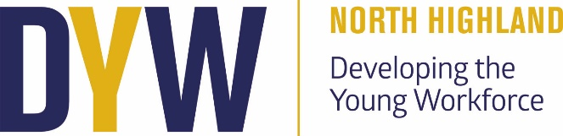

DYW Update
Parent Council Meeting 21/01/2025

Recent Activities:
We’ve had an exciting and productive term with several DYW activities aimed at giving students practical insights into various career pathways.

Murphy Drop-in
Students had the opportunity to engage with a representative from Murphy Construction/Engineering during a drop-in session before Christmas. This informal event let students come along and learn more about careers and opportunities in construction and engineering and ask questions.

World Host Training
Nine students from the Travel and Tourism and Hospitality classes had the opportunity to participate in a full-day World Host Training Course, led by trainer Ellie Lamont. Throughout the day, students explored the key elements of excellent customer care, learning not just about how to provide exceptional service in the hospitality sector but also recognising that we are all customers to one another, even within the school environment.

Venture North Workshop
3 of the team from Venture North ran sessions with the Travel and Tourism class in Thurso. They covered a variety of topics including who they are and what they do within the Tourism industry, marketing, Customer Journey, SMART Goals, and Current Trends. These sessions tied in well with what the students are currently learning about in class, customer service and the promotion of tourist locations.
Lego Renewables Workshop
Fionnadh Carroll from Skills Development Scotland delivered an engaging Lego Renewables workshops for S1 pupils. The sessions provided an excellent opportunity for students to explore the green sector/renewable energy, understand its applications, and discover the growing career opportunities in this dynamic sector. During the workshops, pupils were challenged in pairs to design and build their own wind turbines making sure to test their creations for functionality, all the while examining the skills they were using throughout.

Rolls Royce Meet the Employer
Rolls Royce came in for a meet the employer session. With applications opening in December students could come along and ask questions about careers in engineering, pathways into apprenticeships and beyond and find out about the application process.

S4 Mock Interviews
On December 4th, 2024, S4 pupils took part in Mock Interviews as part of their preparation for future career opportunities. This experience allowed students to practice their interview skills and gain feedback from a diverse panel of professionals.

Coming up

Caithness Jobs Event 2025
Taking place on February 8th, this event is a great opportunity for pupils and parents to explore career options and connect with local employers.

Step into STEM for S2 Pupils
An interactive day where S2 pupils will have the chance to try out various STEM (Science, Technology, Engineering, and Mathematics) skills. This hands-on experience aims to spark interest in these growing fields and help with upcoming subject choices.

Construction Visits with Alistair Bremner from UHI
Alistair Bremner from the UHI will be visiting our Woodwork classes to promote UHI’s construction courses.

Hospitality Class Visit to UHI Kitchens
Our Hospitality class will be visiting the UHI kitchens to gain firsthand experience and learn more about college courses in the culinary and hospitality fields.

We hope to have another productive term with a variety of interested events aimed at helping students in their career journeys. Do get in touch if you have any questions.

Kind regards,
Alice Nicolson

Dyw.north@dywnh.scot

