
THS Curriculum Rationale 2025-26

‘The totality of all that is planned for children and young people throughout their education’ (Curriculum for Excellence)

Background and rationale
We are a fully comprehensive school meeting the needs of all children and young people through high quality mainstream provision and Enhanced Provision base for those with more complex needs. We also support a small cohort of Gaelic Medium pupils who study in Gàidhlig within the broad general education (S1-S3) wherever possible.
As the most northerly secondary school on the Scottish mainland, we work proactively to mitigate the geographical challenges associated with recruitment and, at times, access to services. Despite these challenges, our strong, positive ethos and highly supportive faculties contribute to a very stable staff team; notably, over 50% of our teachers joined us as probationers or newly qualified teachers and have chosen to build their lives and careers here.
Our curriculum is designed to deliver our five school aims including preparing pupils for positive destinations, whether locally or further afield. We take a creative approach to staffing and curriculum delivery, with a strong emphasis on “growing our own” to sustain high quality provision and to meet local needs.

Our Faculties and subjects
English, Modern Languages and  Drama | English, French, Gaelic Medium, Gaelic Learners, Media, Drama
Health and Wellbeing | Physical Education, Practical Cookery, Health & Food Technology, Sport and Recreation, Team Sports, Sports Development
Mathematics | Mathematics, Applications of Mathematics
Music, Business and Computing | Music, Administration and IT, Computer Science, Business Management, Accounting
Pupil Support | Personal and Social Education, individual pupil support
Science | Physics, Chemistry, Biology
Social Subjects | Geography, History, Modern Studies, Politics, Classical Studies, Travel and Tourism, BGE RMPS
Support for Learning | Mainstream support for learning, AAR, Enhanced Provision
Technology and Art & Design | Graphic Design, Practical Woodwork, Engineering Science, Art and Design, Fashion and Textiles Technology

1 To create an ethos of kindness and respect so all pupils feel included, supported, resilient and valued
Our curriculum is underpinned by a strong school ethos of respect and attention to learning based on our TRACK values - Teamwork, Respect, Attainment, Commitment and Kindness. These values are brought to life through our well established THS Classroom Culture, with a recent focus on ensuring that every classroom is fully inclusive. Our Promoting Positive Relationships and Behaviour policy further reinforces the culture of mutual respect we wish to uphold across the school community.
Young people are well supported in their curricular pathways by all staff, particularly their Pupil Support PTs and, where appropriate, Additional Support for Learning staff. A range of nurture and wellbeing supports ensures pupils are ready to learn, and staff maintain awareness of equity factors and protected characteristics, ensuring that these are responded to sensitively in the classroom.
Our House system and pupil leadership programme provide meaningful leadership opportunities and strengthen pupil voice. Health and wellbeing is delivered through dedicated lessons in S1–S2, the PSE curriculum from S1–S5, and through wider subject areas. We assess wellbeing holistically using the Glasgow Motivation and Wellbeing Profile which links to the theory of motivation and can support children to self- evaluate their own wellbeing in line with the principles of GIRFEC.
A wide range of extra-curricular opportunities—including sport, music, debating, Gaelic medium activities and many others —enables pupils to develop skills, achieve beyond the classroom, and benefit from experiences both within and beyond the county.

2 To set high expectations for attainment, achievement, behaviour, attendance and punctuality
We maintain high expectations for pupil and staff behaviour, supported by our THS Classroom Culture and consistently applied school and classroom procedures, now strengthened by our new mobile phone policy. Staff uphold consistent routines and demonstrate respect for all young people, separating behaviour from the individual and showing unconditional positive regard for all pupils.
Our positive presentation policy aims to ensure we have the highest expectations and aspirations for our learners academically. Presentation in the Senior Phase builds on the secure foundations of the Broad General Education and should always allow young people to achieve at the highest possible level.
Pupils are supported to study effectively through an S1–S6 Study Skills programme delivered in PSE and through Assemblies. Parents are also invited to sessions on ‘How to support your child to study’.
We use data systematically—including SNSA, ACEL and Insight—to track progress, with a thorough annual Insight review informing next steps and improvement priorities. Attendance is monitored closely for all pupils, and our Attendance and Family Support Lead works with identified young people and families to support improvement.

3 To provide quality learning and teaching experiences for all
Through our teaching staff Leads we have a very well established, planned whole school CPD on Research Informed Teaching improvement based around our Lesson Evaluation Toolkit teaching framework that allows all staff to work towards improvement in identified areas where required and supports the delivery of consistent and high quality learning experiences for all.
Lessons are structured through the Toolkit with support and challenge to meet the needs of our learners. All staff are aware of the individual needs of some learners and adapt teaching accordingly.
Subject curricula are developed to support and stretch children and young people through the Broad General Education (BGE) and prepare them for success in the Senior Phase (SP).

4 To provide an engaging, challenging and creative curriculum for all learners
Broad General Education
Our transition arrangements from P7 to S1 introduces our first year pupils to a fixed curriculum in S1 and S2 covering all the Curriculum for Excellence curricular areas as well as literacy, numeracy and health and wellbeing.

Expressive Arts – Art and Design, Drama, Music
Health and Wellbeing - Physical Education, Food and cooking, Personal and Social Education
Languages – French, Gàidhlig Medium
Mathematics
Religious and Moral Education
Sciences
Social Studies - History, Modern Studies, Geography
Technologies - Fashion and Textiles, Computing, Woodwork, Graphics, Business

Digital skills are taught explicitly in the BGE through Computing allowing pupils to make best use of their Chromebooks and Google Classroom as well as other Apps.
Towards the end of S2 pupils are able to deepen their learning and personalise their curriculum to some extent for S3 with Maths and English and six subject choices. Throughout S3 teaching follows the BGE with opportunities where appropriate for learning to be aligned to National courses.
Our plans for session 2026-27 include offering an S3 alternative curriculum more suitable for a small group of disengaged learners who are not accessing our provision in order to support them to attend and attain more fully.
Young people further personalise their curriculum towards the end of S3 to take a minimum of six National Qualification courses, including Maths and English, in S4.
At all option points pupils are supported by PTPSs and Year Heads to review their learning and plan for progression and next steps. Parents play a key role with information sent home through tracking, an options information evening and options drop in session and our dedicated Options website https://sites.google.com/thursohigh.org.uk/coursechoiceinformation/home?authuser=0.
For more info see the document THS S2-S5 Options procedures information 2025-26.
We believe that our BGE curriculum prepares pupils well for a successful transition into the Senior Phase.

Senior Phase
Our Senior Phase is fully integrated apart from S4 Maths and English, allowing pupils to study at the appropriate level regardless of stage and our range of choices to be as wide as possible.
Wherever possible we try to offer opportunities at all levels with a wide range of courses in subjects that enable progression pathways for all abilities including our Enhanced Provision pupils.
For example, subjects recently added to allow further opportunity include Fashion and Textiles Technology, Barista Skills, Health and Food Technology, Classical Studies and Sports Development.
We have good positive destination figures with over 95% of young people in session 2024-25 leaving to positive destinations.
Skills Development Scotland provide staff and Senior Phase pupils with up-to-date labour market information and how this is relevant when considering post school pathways.
In S4 pupils study a minimum of six subjects leading to National qualifications plus Personal and Social Education (PSE) and Physical Education (PE)
In S5 pupils study five subjects plus PSE and PE
In S6 pupils must study a minimum of four subjects alongside the S6 Opportunities programme which is offered as an option that almost all pupils take advantage of, allowing them to take leadership roles and support the running of the school through such activities as Subject Ambassadors, S1 Mentoring, paired reading, Mentors in Violence Prevention and support in the Enhanced Provision.
From session 2026-27 every pupil in Senior Phase will have a weekly core period following a DYW programme of support aligned to their future pathways – employment, apprenticeship, university.
All pupils in the SP benefit from UHI’s adjacency to the school through a School Link programme that runs on a Friday, with curricular structure adaptations to allow for this with approximately a hundred pupils attending these courses over the Senior Phase. Some of the most popular choices through UHI allow young people to attain qualifications in vocational areas such as Engineering, Construction, Hospitality and Hair and Beauty.
Through the school and UHI pupils study a wide range of subjects from SCQF levels 1-7 (National 1-5, Higher, Advanced Higher), Skills for Work courses, National Progression Awards and Foundation Apprenticeships.
Thurso High School is committed to developing appropriate individualised pathways for pupils to enable them to meet their potential through adapted timetables if required and in partnership with University of the Highlands and Islands, Highland Council Digital School, e-Sgoil or YASS (Young Applicants in Schools Scheme). Adaptations also include off-site provisions such as Airport House or individual Additional Support Needs teacher support, third party support such as Home to Highland, Highland Tutoring Service for pupils with interrupted learning, initiatives such as Growing2gether and work experience.

Enhanced Provision
Our pupils in the Enhanced Provision (EP) experience a broad and meaningful range of personal achievements, following a highly individualised curricula.
Through gaining a variety of qualifications from National 1 to National 3 levels - including Communication, Science, Performance Arts, Mathematics, Classics, Cookery, Textiles, Employability and more - young people in the EP are also developing key emotional and social skills, including emotional regulation and the ability to work effectively with others. Where appropriate, pupils are now able to make connections between their achievements in school and the skills they will need for their future lives.
A few young people in the EP enjoy participating in wider school initiatives such as cookery, horse riding, music tuition, and college link. Almost all take pride in their accomplishments and grow in confidence and resilience as a result.
Planned pathways into full courses include N2 Business in Practice with its three mandatory units and N3 Art & Design providing coherence and added value.

5 To ensure all pupils leave Thurso High School to a positive and sustained destination
Our young people all follow a carefully considered Career Skills curriculum as part of their Personal and Social Education time in S1-5, based on the Career Education Standards. To support this, Skills Development Scotland staff and our Developing the Young Workforce Coordinator also visit all register sets to ensure they are known and visible to all pupils and that our young people are aware of where to access support and about online resources such as My World of Work and, for Senior Phase pupils, the work experience website used throughout the local authority.
Additionally, we have a planned calendar of Developing the Young Workforce events throughout the academic year which complement our curriculum.
We consistently collaborate with external partners to support our young people into positive destinations. Almost all pupils, including our pupils with Additional Support Needs and in receipt of free school meals, move into positive destinations, in line with or above comparator data.
16+ pathway planning meetings are held in terms two and four to ensure that both winter and summer leavers are well supported with their options and chosen destinations. The structure of these meetings ensures a continued focus on groups of pupils who may require more targeted support including Care Experienced Pupils and those with alternative educational provision.
Pupils will have the opportunity to attend classes to support them with university, college or apprenticeship applications in addition to Developing the Young Workforce (DYW) provision planned throughout the year. We also have strong links with Airport House, Highland Tutoring Service and Home to Highland to support pupils where appropriate. Skills Development Scotland supports all pupils.
The upcoming introduction of the ‘Unifrog’ platform will support pupils to recognise and articulate the skills and attributes gained both in and beyond the classroom.

Appendix 1 THS Curricular structure diagram
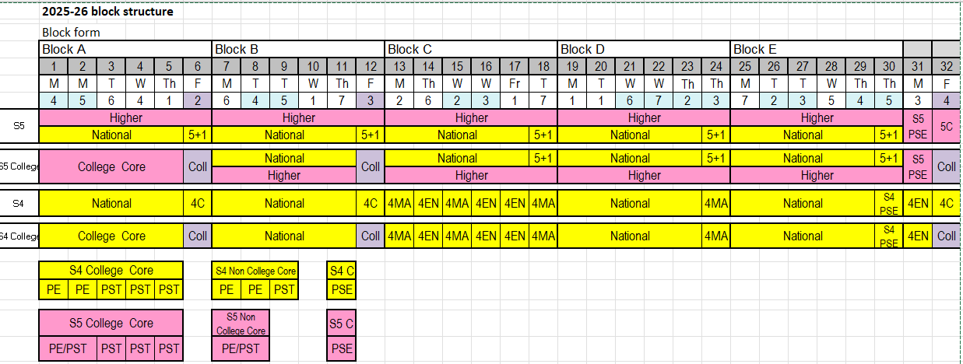

Appendix 2 Example of subject pathway diagram
